

**Developer**: Tyler Ernest

**Date**: 5/27/2023

# IT 145 Global Rain Summary Report

## Pseudocode

Check In Method

---------------------------------

Prompt user for info is Pet New or Returning?

IF Returning

get stored pet info

IF info is the same and space is available

Check in pet

ELSE IF info outdated

Prompt for new info

ELSE IF New

Prompt to enter pet info

IF pet is Dog

IF no space available

No Space for pet

ELSE

prompt for info

Name, Age, Weight and Length of stay.

IF Length of Stay is greater than 2 days

Ask if grooming

IF yes

set dog to be groomed

Else

set dog to not be groomed

Check In Dog

ELSE IF pet is Cat

IF no space available

No space for pet

ELSE

prompt for info

Name, Age and Length of Stay.

Check In Cat

## Flowchart

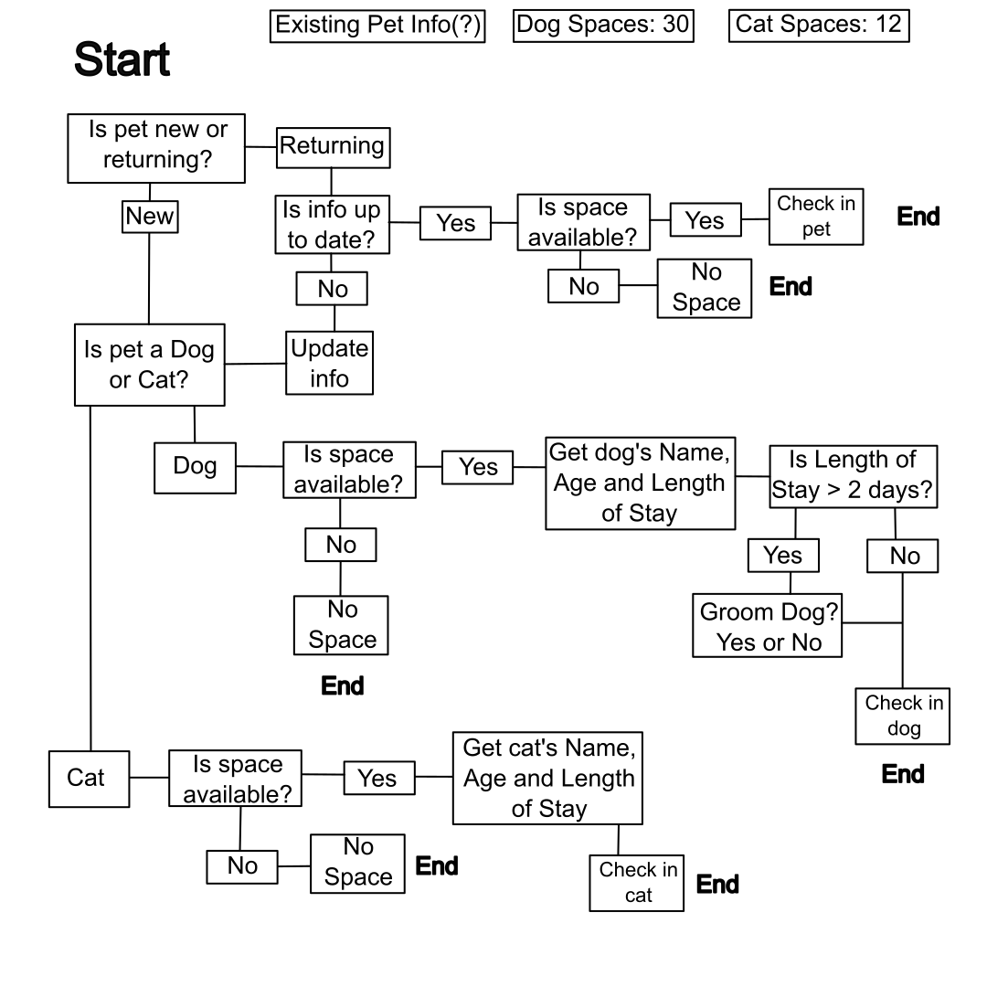

## OOP Principles Explanation

Creating the pet class is a general Abstraction that represents the pet to check in. These class attributes then can be Inherited by the following dog and cat classes. The attributes of the pet class and subsequent dog and cat classes are private so they won’t be altered. Instead they can be updated via public methods, Encapsulating the internal classes for protection. The data from the pet class can be implemented to the classes that inherit from it. Since Dog and Cat classes are Abstractions as well, they utilize polymorphism.